[South China Sea](https://www.google.com/search?safe=active&sca_esv=563733001&cs=0&q=South+China+Sea&stick=H4sIAAAAAAAAAEVSPY_TQBT0RkpwHBCJjyJKZUVCiiKk2E5sxxRcpKM9RZBD0EWJP2LH3vXHmrOdkl-AKKgRBaLgF1CgEx0pQFAgKorrKNC1h4QEcdg1W41mZ-a9ffvYapcdwIG4TuBYbmJrIbhISBxLSIPYN7dgfymr0pDAEU4zAiUxpYLCTVlFlkvoaASqa5tqJeh7W1Df58YbJSa0nXkaoaVE1ERCm7YoEbgaIoMqxhgiQit6lFLaQyKmFVVpU2aMbAIdpOtbwO3jlBEaOoQ3lHhX_UoBwzl9oCF6Zafm2jilVXyE6Di0ONapJMMmJljZnNqQ5HlyRBWrHPsUp1pWtq3YUC-foIY0RTbmxdz33cqRpmhlUC5GIf0QPaY5CsLZnGBVNXyRyseo7EzOotD8H2OM6BSXa5taM-xBOiR7ZUNaVoL5OKFeFIsJ8XompnOS5LGkEK-SiPmG7oI3d5bn4Bw0mj8uvx90voFnbz58BZ8BV39YLFrqmhY_5RozKzkJjgPTtXN-wt_h6scWXFoxntp8l-OOAt-3jMQNEH-jw3PNgVESg93q4u61-__-HoXZGah0PfnB2y_PP9amLWZ3HtXuTTq9four3Q3gwkWtn02GefXn4rB_wLEniyxAAcxbl58qL_RfF4fddmGa_K7enLQbAtNjpCIjutU-6zO77CfvXr-vNVjQZOQqy_CgcrvSA5sKy1x9Wb0-Cx4njnDkuGghzKzF0xr4C53LYv5nAwAA&sa=X&ved=2ahUKEwjY6e_um5uBAxV2cmwGHaolA2YQ7fAIegUIABDSBQ)

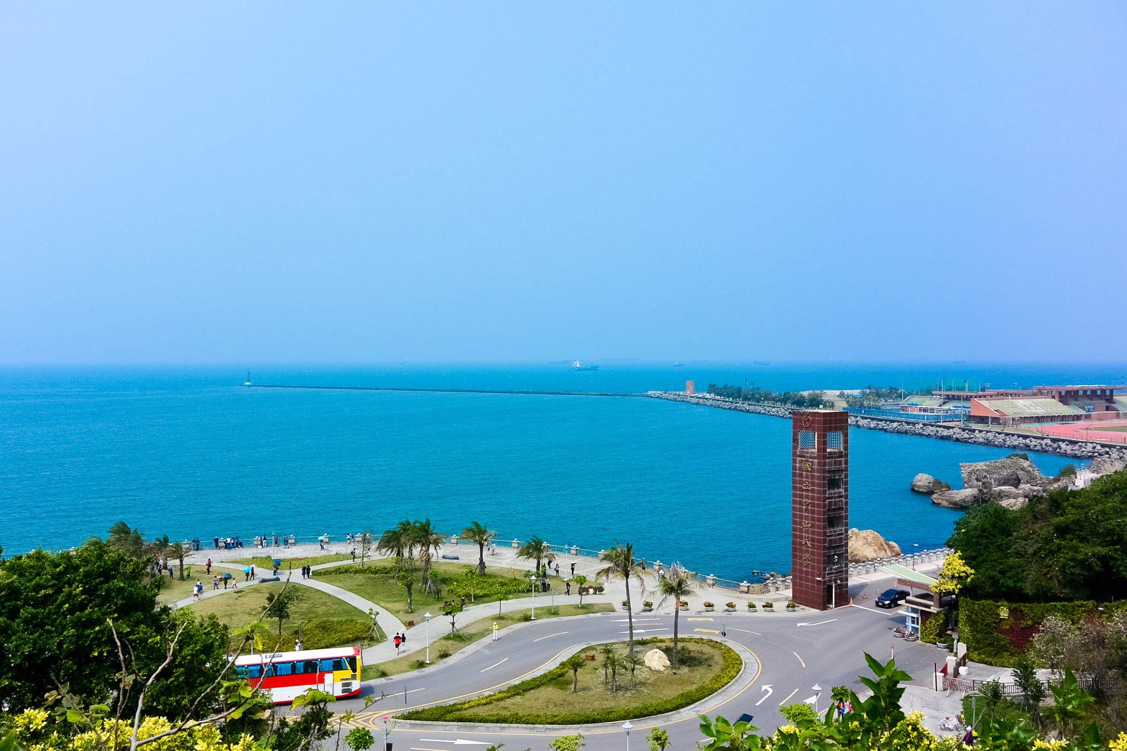

southchinasea.png

The South China Sea is a highly disputed and strategically significant body of water in Southeast Asia. Covering an area of about 1.4 million square miles (3.6 million square kilometers), it is bordered by China, Vietnam, the Philippines, Malaysia, Brunei, and Taiwan. The region is rich in natural resources, including oil and natural gas, and is a vital shipping route for global trade. However, territorial disputes among neighboring countries, particularly China's expansive claims, have led to tensions and conflicts. The South China Sea is a focal point in international geopolitics, with ongoing disputes over sovereignty, freedom of navigation, and the potential for military confrontations.

Example of marine life

1. Manta Rays

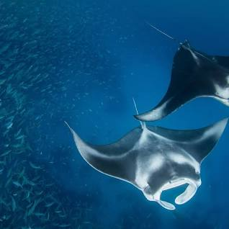

mantarays.png

1. Coral-Eating Crown-of-Thorns Starfish

